**E Commerce sadhBoard**

Wireframe Documentation

E Commerce Sales DashBoard

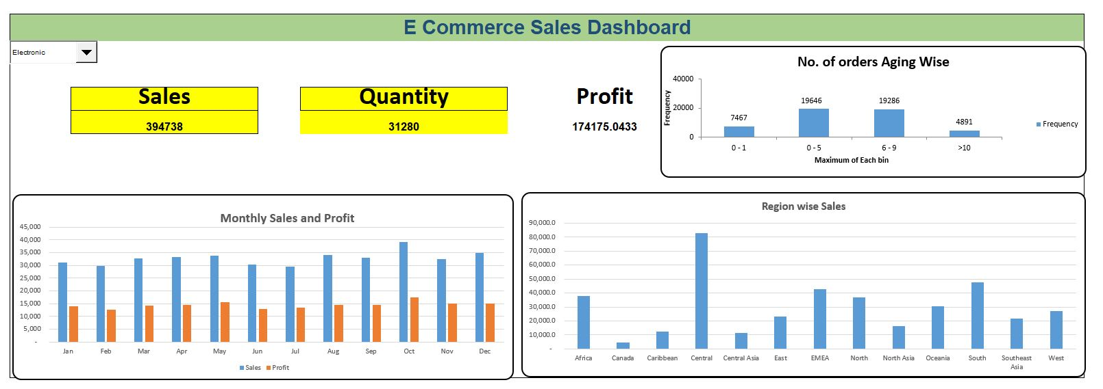

E Commerce dashboard

This is E-commerce Dashboard

In this dashboard we have calculated

1. No. of order aging wise
2. Monthly Sales and Profit
3. Region wise Sales

No. of order aging wise

Monthly Sales and Profit

Region wise Sales